Name : Sundara Moorthy
Reg No : 192324228
Course code : Cloud Computing And Big Data Analysis
Exp No : EXPERIMENT 16
Date : 23/12/2025

16. Creation and Testing of Virtual Machine Cloning
Aim
To create a clone of an existing Virtual Machine and test the cloned VM using VMware Workstation.
Steps
- Power OFF the original Virtual Machine.
- Right-click the VM → Select Manage → Clone.
- Click Next in the Clone Wizard.
- Choose Clone from current state.
- Select Full Clone.
- Provide clone name and storage location.
- Click Finish.
- Power ON the cloned Virtual Machine.
Output
• Clone of the Virtual Machine successfully created.
• Cloned VM runs independently of the original VM.
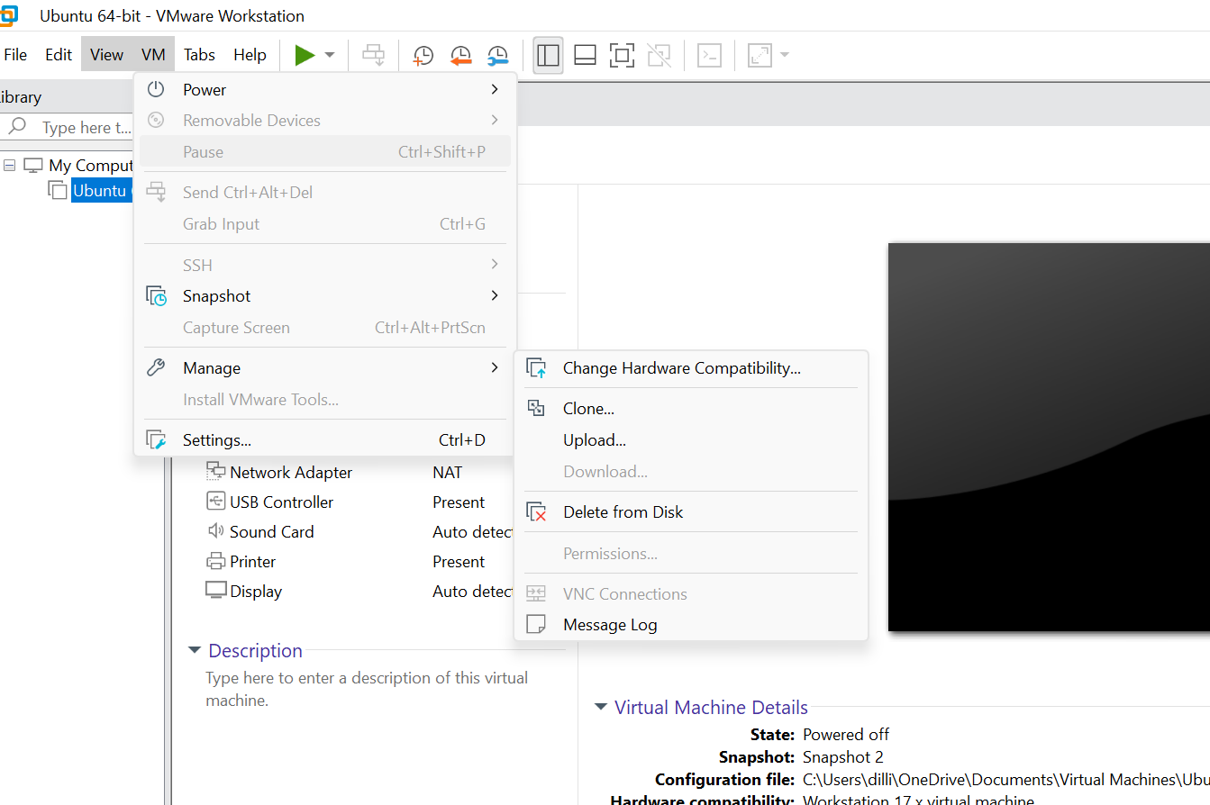

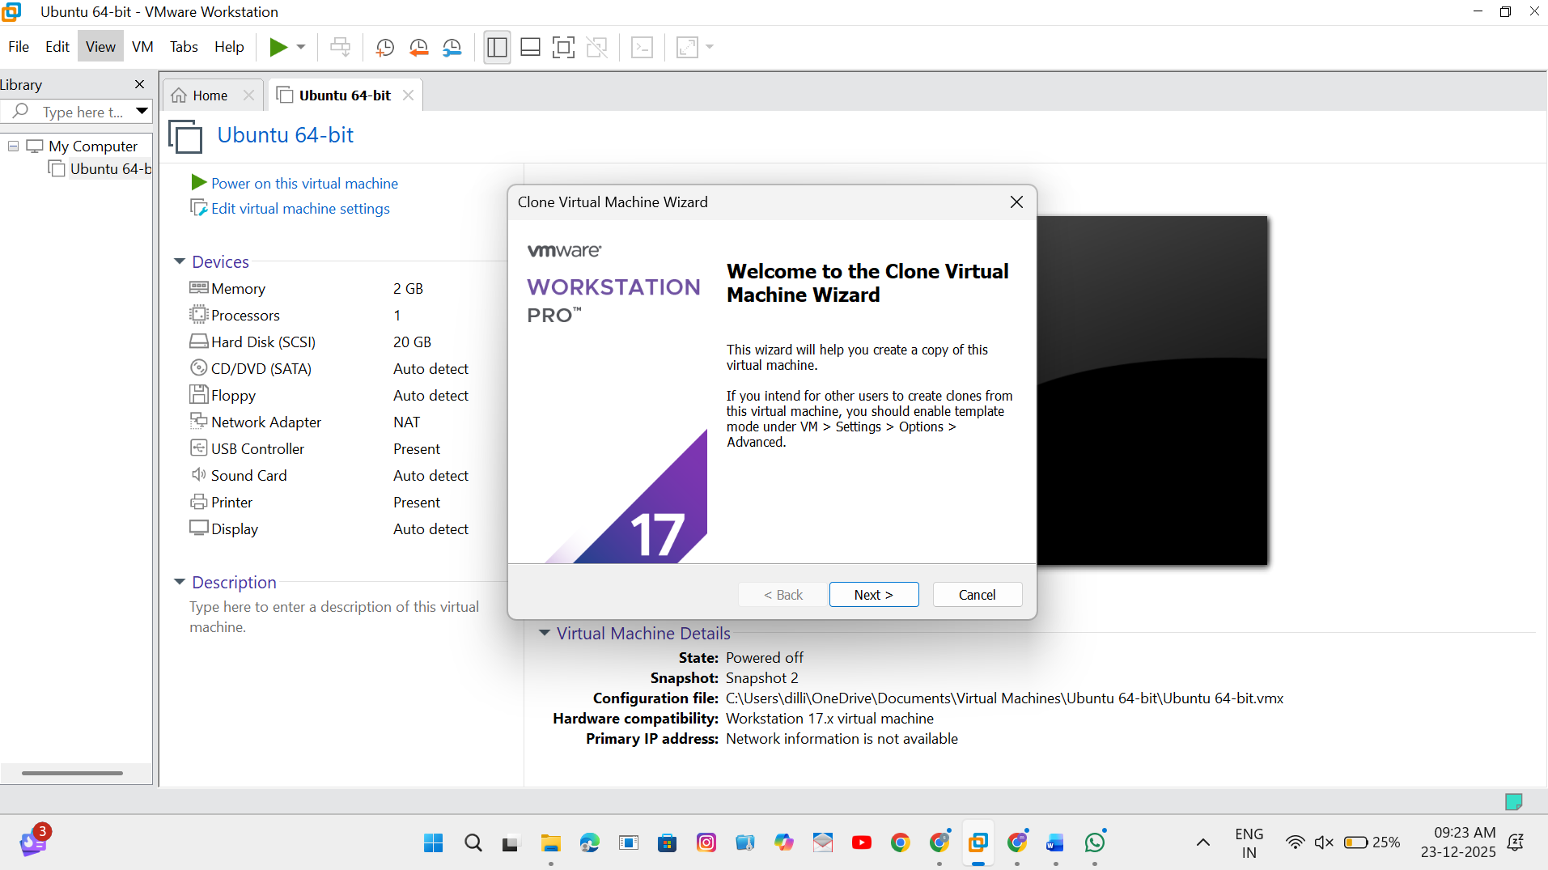

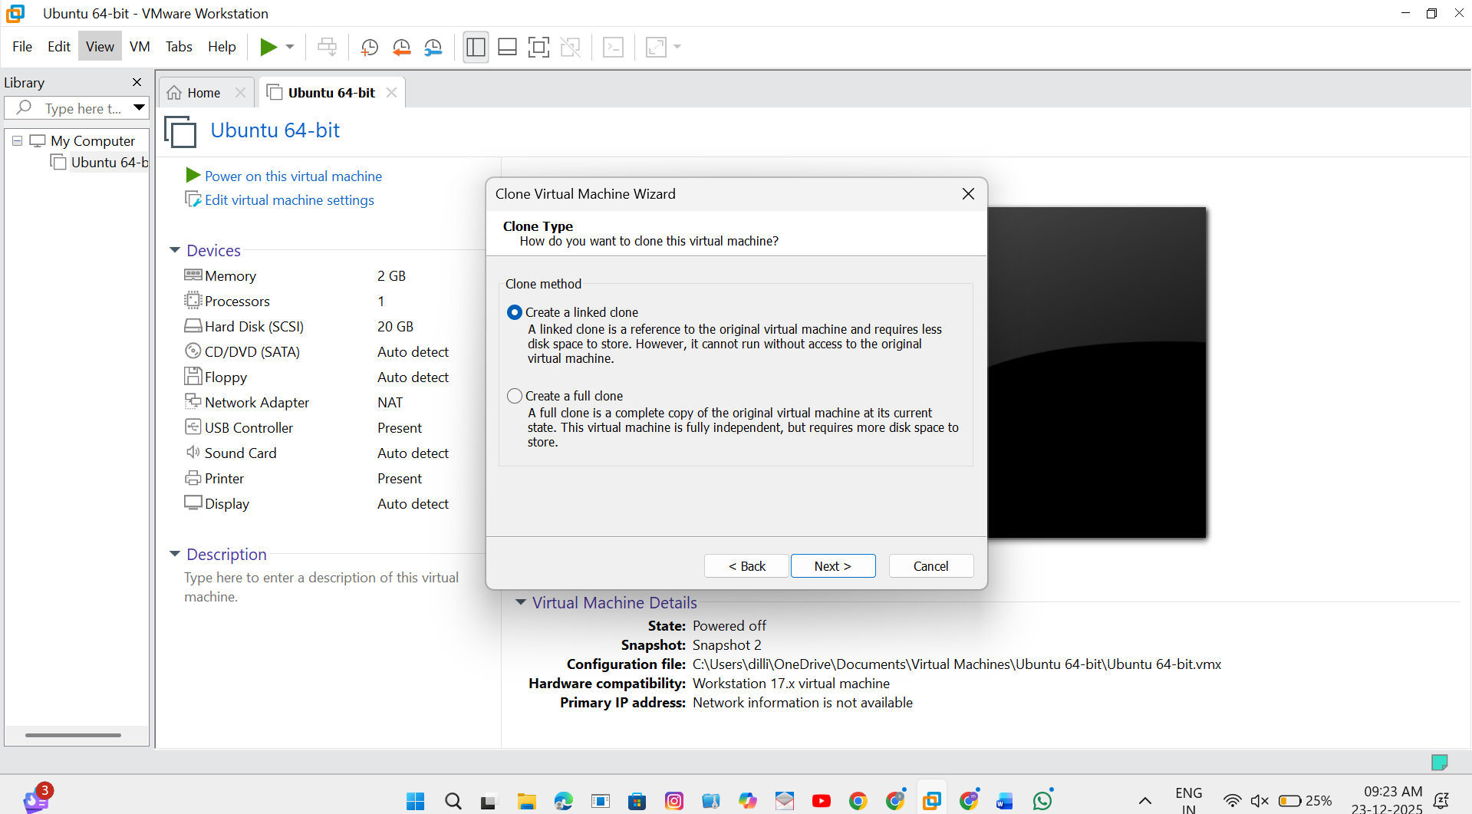

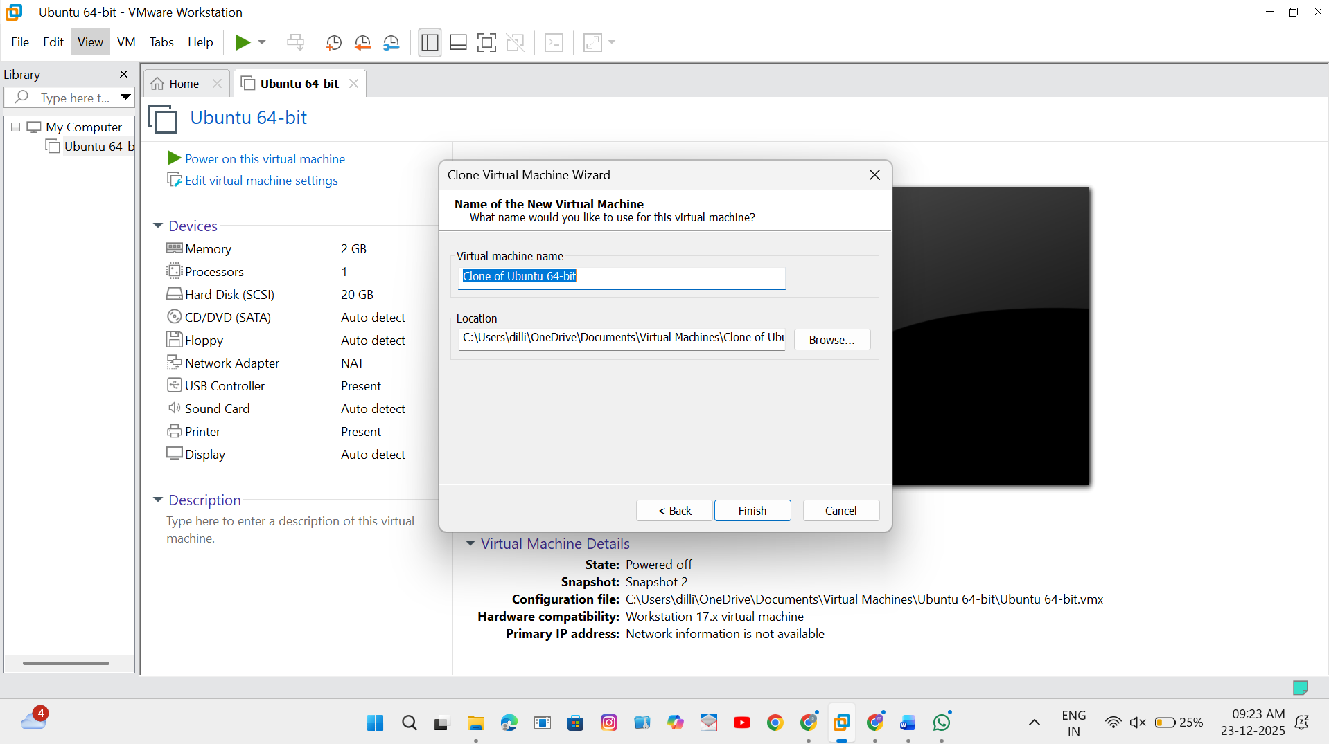

Result
Thus, Virtual Machine cloning was successfully performed using VMware Workstation.

